

Welcome

*to the*

1303 Retreat

1303 13th Avenue NW, Rochester, MN 55901

We are so happy you chose to stay in the 1303 Retreat – your home away from home! Your comfort is our priority. This book includes information you may find useful during your stay. If you have any questions, or if there’s anything we can do to make your stay more enjoyable, please do not hesitate to contact us.

Best Wishes,

Aaron & Whitney

Cell: 612-423-5755 (call or text)

Have pictures you want to share during your stay? Share them at www.facebook.com/1303retreat

w

Email: [whitneyleesimon@gmail.com](mailto:whitneyleesimon@gmail.com)

Airbnb link Website

Table of Contents

check-in & Check-Out 3

Check-In 3

Using the Smart Lock 3

Keypad 3

August Home App 3

Locking/Unlocking the Door From Inside 4

Check-Out 4

Amenities 5

Internet 5

TV 5

Streaming Netflix, Hulu, Amazon Prime, Etc. Using Roku 5

Using Blu-ray Player 6

Thermostat 6

Laundry 6

Children’s Amenities 7

Crib/Pack ‘N Play 7

High Chair 7

Garbage 7

Extra Supplies 8

First Aid Kit 8

Garage & Parking 8

Linens 9

Bed linens 9

Bath Linens 9

Sleeper Sofa 10

General Information 11

Entrances Onto Property During Your Stay 11

Snow Removal 12

Lawn Mowing 12

Transportation 13

Rochester Public Transit 13

Taxi Services 13

Restaurants 14

House Rules 15

Smoking 15

Pets 15

Illicit Drugs 15

Noise 15

Occupancy 15

Weapons 15

Cleaning 16

Crime-Free Lease Addendum 16

# check-in & Check-Out

## Check-In

* **Check-in time is at 3:00 P.M. or after**, unless alternate arrangements have been made ahead of time.
* Enter the house using the code provided to you before check-in or by using the August Home app on your phone (instructions below).

## Using the Smart Lock

You can use the key pad or the August Home app on your phone to enter the house. If both of these methods of entry fail, open the lockbox (located on the left door frame between the two front doors (above the black smart lock keypad) to retrieve the hard keys using the code provided to you.

### Keypad

The keypad is located on the left door frame between the two front doors (between the glass/screen door and the front door). To use the keypad, enter the code you were given, followed by the red button at the bottom of the keypad. This will unlock the door. The same process will lock the door.

Note: your keypad code expires after you check out. This prevents previous guests from being able to enter the home past their stay.

### August Home App

This app controls the smart lock on the front door. You can always use the keypad in place of the app if desired.

Instructions:

1. You will receive an invitation by email or text message with instructions on how to download and use the August Home app on your phone.
2. Follow the instructions on your phone to enter.

### Locking/Unlocking the Door From Inside

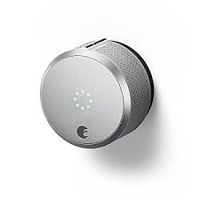The smart lock takes the place of the deadbolt. To lock or unlock from inside of the house, turn the August Smart Lock to the right to unlock and to the left to lock.

Lock

Unlock

## Check-Out

* **Check-out time is by 11:00 A.M.**
* Leave keys (if used) and garage door opener on kitchen table
* Log out of your TV streaming accounts if used (Netflix, Amazon Prime Video, Hulu, etc.)
* Turn TV and lights off
* Wash your dishes
* Throw away opened food items. You may leave unexpired and unopened food items. Seasonings, etc. may be left if opened only if they’re unexpired and clean.
* We will take care of the washing of the linens after your stay, but we ask that you keep things as clean and orderly as possible during your stay to help us keep our home in great shape
* Please leave us a review on the site you booked on (Airbnb, Booking.com, Expedia, HomeAway/VRBO, etc.) and facebook.com/1303retreat!

# Amenities

## Internet

Network name: MySpectrumWiFi28-2G

-or-

MySpectrumWiFi28-5G (this one is faster!)

Password: blueship225

## TV

The TV has a Roku streaming device and a BluRay player connected to it. The Roku device will allow you to access your Netflix, Hulu, Amazon Prime Video, etc. accounts. *Please be sure to log out of your accounts before checking out.*

**Remotes:**

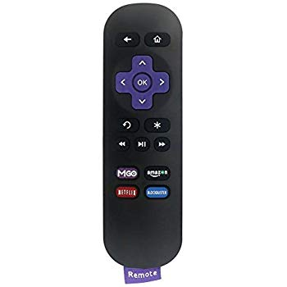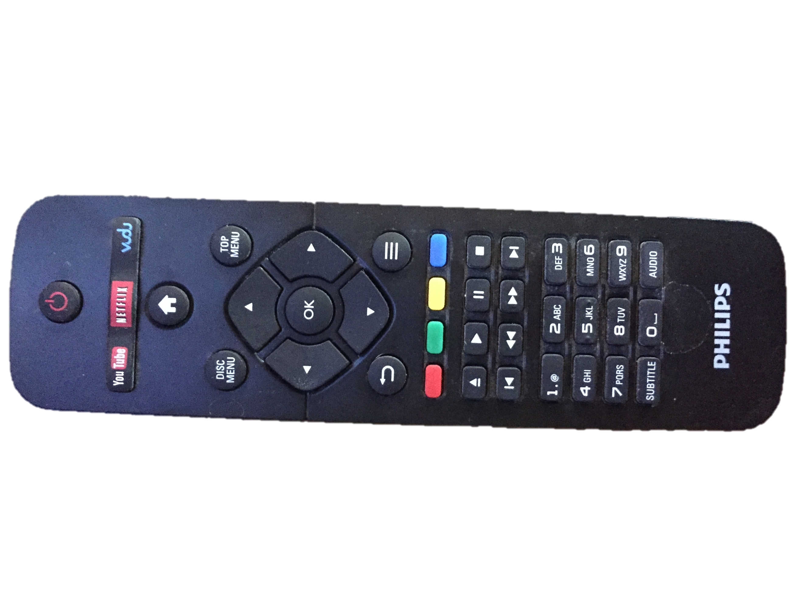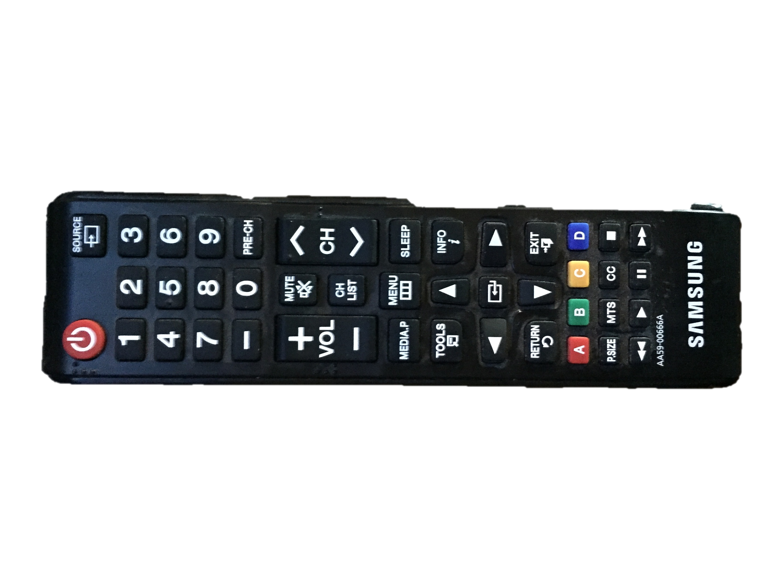

Philips Remote

Roku Remote

Samsung Remote

### Streaming Netflix, Hulu, Amazon Prime, Etc. Using Roku

1. Turn power on TV (Samsung remote)
2. On Samsung remote, click “source” (top right), and then select “HDMI1” on screen
3. Roku screen will come up
4. Navigate to your streaming service of choice and sign in

The Roku player should already be connected to the internet, but if it gets disconnected, see the “Internet” section of this book for the network name and password.

### Using Blu-ray Player

1. Turn power on Philips Blu-ray player (Philips remote) and TV (Samsung remote)
2. On Samsung remote, click “source” (top right), and then select “HDMI2” on screen
3. Use Philips remote to control Blu-ray player

## Thermostat

xx

## Laundry

A washer and dryer, along with laundry detergent and bleach, are provided in the basement. Please clean the lint trap after each use.

*Note: We will wash the bed linens and towels after your stay to ensure they meet our quality standards.*

## Children’s Amenities

* Pack ‘N Play
* High chair
* Sippy cups, utensils
* Toys and books
* Dishes are not breakable, so can be used by kiddos too!

A Pack ‘N Play and high chair available for your use. The locations of these items are noted below. Please use these items safely. We will not be responsible for injuries or harm caused by misuse or defects of these products. Some reminders for using these items safely are below. These lists are not exhaustive.

### Crib/Pack ‘N Play

* Located under twin bed near window in bedroom with two twin beds
* Clean sheets are in two plastic bags inside of the Pack ‘N Play bag
* Do not place near window blinds, as the string for window blinds is a strangulation hazard
* Follow appropriate guidelines for SUID (sudden unexplained infant death syndrome) prevention

### High Chair

* Located in basement at bottom of stairs against wall
* Never leave child unattended
* Use proper precautions to avoid choking while child is eating in chair
* Use buckles to secure child in high chair

## Garbage

Please separate regular trash and recycling. Garbage may be taken out to the large trash bins located on the back patio. Please see the “Entrances to Property During Your Stay” section regarding garbage pick-up.

## Extra Supplies

Supplies, including towels, washcloths, hand towels, toilet paper, paper towels, facial tissues, batteries, and light bulbs are in the closet in the upstairs hallway. Please ONLY take items needed during your stay. We work on the honor system and we choose to trust our guests; however, we do take inventory after each stay.

## First Aid Kit

A first aid kit is in the closet in the upstairs hallway.

## Garage & Parking

One of the attached garage stalls (the one nearest to the rest of the house) is available for guests to use. The code to enter the garage is 1124 and then press “Enter.” The garage door opener will be on the kitchen table upon your arrival. Please remember to leave the garage door opener on the kitchen table before checking out. Loss of garage door opener will result in a $30 fee.

Parking on the driveway is also permitted.

**In the case of snow:**

* **DO NOT PARK ON THE STREET IF THERE IS SNOW. The city could tow your vehicle or issue a ticket if plowing becomes necessary.**
* **Please park in the garage to allow the snow removal crew to clean the driveway. If you have more than one vehicle, park the second vehicle in front of the second garage stall so that the majority of the driveway can still be plowed.**

**More information regarding snow removal can be found in the “****Entrances to the Property During Your Stay****” and “****Snow Removal****” sections.**

## Linens

### Bed linens

Our mattresses and pillows are covered in waterproof protectors at all times. All bed linens are washed with bleach after each stay, and the comforters are washed as well.

**Please allow us to wash the bed linens** to ensure they meet our cleanliness and quality standards. If you must wash the linens during your stay, please make sure the mattresses and pillows are *covered with waterproof protectors as well as sheets whenever they’re in use*.

**Extra linens**, warm cotton blankets, and mattress and pillow protectors can be found in a labeled bin in each bedroom closet. We will replenish these bins after your stay. We ask that you do not return linens to these bins so we can be sure they only contain linens that meet our cleanliness quality standards.

**Clean bed cards** are used to indicate clean beds. Please leave these cards on any beds that were unused during your stay so we can save resources and avoid re-washing already clean bedding.

**Sleeper sofa** linens are in the queen bedroom closet (the room at the end of the hallway). Instructions for using the sleeper sofa are in the “Sleeper Sofa” section below.

### Bath Linens

Bath linens are in the closet in the upstairs hallway.

Please use black washcloths for makeup removal, as some makeup resists bleach and stains white washcloths.

Please hang in-use towels on the hooks in the bathrooms or bedrooms (behind doors), and avoid leaving towels on the wood floors, as it will ruin them. Leave used towels and washcloths in the receptacle in the upstairs hallway.

## Sleeper Sofa

The sleeper sofa is a queen-sized bed. To use, ***carefully*** remove the slipcover on the couch, remove cushions, and pull out the sleeper sofa.

Pillows and linens for the sleeper sofa can be found in the closet of the queen bedroom (the bedroom at the end of the hallway upstairs). The linens are in a labeled bin.

Please keep the mattress encasement on the mattress at all times, even before checking out (this will be on the mattress before you arrive). In addition, keep the waterproof mattress and pillow protectors on at all times (these can be found in the linen bin mentioned above and will already be on the pillows in the closet.)

# General Information

## Entrances Onto Property During Your Stay

People may be on the property during your stay for the following reasons:

* Garbage pick-up
  + Aaron or Whitney (owners) or back-up personnel will be there on **Thursday mornings** to take garbage bins out to the end of the driveway.
  + Waste Management will be there on **Fridays** to dispose of garbage.
  + Aaron or Whitney (owners) or back-up personnel will be there on **Friday afternoons or evenings** to return garbage bins to the back patio.
* Snow removal
  + Elite Outdoor Solutions LLC is our snow removal company. They will be at the house to shovel/plow when needed. More information is in the “Snow Removal” section below. Please view this section for important parking information if snow is in the forecast!
  + Whitney will be there to sprinkle salt/sand mixture on the sidewalk and driveway as needed when she is available.
* Lawn mowing
  + Elite Outdoor Solutions LLC is our lawn mowing company. They will be at the house to shovel/plow when needed.
* Anyone in case of an emergency (you will be notified if someone will be entering the house for an emergency repair)

## Snow Removal

Elite Outdoor Services LLC is our snow removal service. They will be at the house as necessary for snow removal. If snow has not been removed in a timely manner, please call us. A shovel is provided in the garage if needed, but we do not expect you to be responsible for snow removal.

**A salt/sand mixture** with a scoop is located in a bucket on the patio near the front door to melt ice and provide friction and prevent slipping on the ice. I will come by to sprinkle the sidewalk and the left side of the driveway when needed whenever I am available. Feel free to do this yourself as well if needed.

**If snow is in the forecast, please park in the driveway.**

* DO NOT PARK ON THE STREET, as the city could tow your vehicle or issue a ticket if plowing becomes necessary.
* Do not park in the driveway so the snow removal crew can clean it off

## Lawn Mowing

Elite Outdoor Solutions LLC is our lawn mowing service. They will be at the house as necessary to mow lawn.

## Transportation

### Rochester Public Transit

Rochester Public Transit’s website is: <https://www.rochestermn.gov/departments/public-transportation>

Our home is on route 11 during the week, and route 22 on Satudays, Sundays, and holidays. See this link for the complete bus schedule (current as of 11-16-18): <https://www.rochestermn.gov/home/showdocument?id=16522>

**Fares**: As of 11/16/18, fares are $2/adult and $1/child (6-18 years old; 5 and under ride free). Passes can be bought for discounted rates. See current rates at <https://www.rochestermn.gov/departments/public-transportation/bus-fares>

**Bus tracking**: You can download Rochester Public Transit’s app for live bus tracking and to plan your route. More information is here: <https://www.rochestermn.gov/departments/public-transportation/real-time-bus-tracking>

### Taxi Services

RST Taxi Service: <http://www.rsttaxiservice.com> 507-316-0955

## Restaurants

**Canadian Honker Restaurant**

“Busy veteran eatery serving breakfast as well as a menu of American eats including prime rib.”

1203 2nd Street SW

Rochester, MN 55902

507-282-6572

<http://restaurant.canadianhonker.com>

**Chester’s Kitchen & Bar**

“Modern destination features upscale American fare & cocktails in a stylish venue with patio seating.”

Shops at University Square

111 S Broadway #108

Rochester, MN 55904

([507) 424-1211](https://www.google.com/search?client=safari&rls=en&q=best%20restaurants%20in%20rochester%20mn&ie=UTF-8&oe=UTF-8&npsic=0&rflfq=1&rlha=0&rllag=44022164,-92472057,759&tbm=lcl&rldimm=12716644167558729225&lqi=CiBiZXN0IHJlc3RhdXJhbnRzIGluIHJvY2hlc3RlciBtbiIDqAEBWg0KC3Jlc3RhdXJhbnRz&ved=2ahUKEwjJiYvn49reAhVhpIMKHYaHBbgQvS4wAHoECAAQPQ&rldoc=1&tbs=lrf:!2m4!1e2!5m2!2m1!2e8!2m1!1e5!2m1!1e1!2m1!1e3!2m1!1e16!3sCgIIASAB,lf:1,lf_ui:9)

[www.chesterskb.com](http://www.chesterskb.com)

**Pescara**

“Spacious dining room & bar serving refined seafood dishes, chops & steak in an upscale setting.”

150 S Broadway

Rochester, MN 55904

(507) 280-6900

# House Rules

We ask that you adhere to our house rules to ensure your safety, the care of our property and house, and the respect of our neighborhood and community. Not adhering to these rules is grounds for a reflective review on the vacation rental platform you reserved through, as well as being reported to the platform and/or the proper authorities.

## Smoking

Smoking is not allowed in the house or in the garage. Smoking outside is permitted *when the doors and windows are closed*. Cigarette butts *must* be disposed of in an appropriate receptacle. Please do litter cigarette butts or put cigarettes out on the cement or other property that could be damaged by it.

## Pets

Pets are not allowed on the premises.

## Illicit Drugs

Illicit drugs are not permitted anywhere on the property.

## Noise

Please keep the noise to a minimum, especially during late night and early morning hours, to respect the neighbors.

## Occupancy

The house is able to accommodate 7 people. Please let us know if you expect more people than noted in your reservation.

## Weapons

Weapons are not permitted on the property.

## Cleaning

* Wash your dishes
* Take trash out to trash bins (near patio)
  + See “Entrances onto Property During Your Stay” in the “General Information” section for information on when trash will be picked up by Waste Management.
* Throw away opened food items. You may leave unexpired and unopened food items. Seasonings, etc. may be left if opened only if they’re unexpired and clean.
* We will take care of the deep cleaning and washing of the linens after your stay, but we ask that you keep things as clean and orderly as possible during your stay to help us keep our home in great shape
* Place used towels in the receptacle in upstairs hallway
* The mop, mop bucket, broom, vacuum, and dust pan are in the coat closet next to the front door

## Crime-Free Lease Addendum

1. Resident, any members of the resident’s household or a guest or other person under the resident’s control shall not engage in criminal activity, including drug-related criminal activity, on or near said premises. “Drug-related criminal activity” means the illegal manufacture, sale, distribution, use, or possession with intent to manufacture, sell, distribute, or use of a controlled substance (as defined in Section 102 of the Controlled Substance Act (21 U.S.C. 802)

2. Resident, any member of the resident’s household or guest or other person under the resident’s control shall not engage in any act intended to facilitate criminal activity, including drug-related criminal activity, on or near the said premises.

3. Resident or members of the household will not permit the dwelling unit to be used for, or facilitate criminal activity, including drug-related criminal activity, regardless of whether the individual engaging in such activity is a member of the household or a guest.

4. Resident, any member of the resident’s household or a guest, or another person under the resident’s control shall not engage in the unlawful manufacturing, selling, using, storing, keeping, or giving of a controlled substance or marijuana at any locations, whether on or near the dwelling unit premises or otherwise.

5. Resident, any member of the resident’s household, or guest or another person under the resident’s control shall not engage in any illegal activity including prostitution, criminal street gang activity, threatening, intimidating or stalking, assault, the unlawful discharge of firearms, on or near the dwelling unit premises, or any breach of the lease agreement that otherwise jeopardizes the health, safety, and welfare of the landlord, his agent or other tenant or involving imminent or actual serious property damage.

6. VIOLATION OF THE ABOVE PROVISIONS SHALL BE A MATERIAL AND IRREPARABLE VIOLATION OF THE LEASE AND GOOD CAUSE FOR IMMEDIATE TERMINATION OF TENANCY. A single violation of any of the provisions of this added addendum shall be deemed a serious violation and a material and irreparable non-compliance. It is understood that a single violation shall be good cause for immediate termination of the lease. Unless otherwise provided by law, proof of violation shall not require criminal conviction, but shall be by substantial evidence of the type reasonably relied upon by property managers in the usual and regular course of business.

7. In case of conflict between the provisions of this addendum and any other provisions of the lease, the provisions of this addendum shall govern.

CITY OF ROCHESTER ORDINANCE # 38.152

It is the responsibility of owner/landlord/management to see that person occupying the licensed property conduct themselves in a manner as not to cause the property to be disorderly. For purposes of this ordinance a property is disorderly when any of the following activities occur:

R.C.O. Sec 34.20-34.27 Overcrowding

R.C.O. Sec 85.01 Prostitution

R.C.O. Sec 85.02 Indecent Conduct

R.C.O. Sec 85.04 Participation in Disorderly House

R.C.O. Sec 85.10 Loud Parties, gatherings or other unnecessary loud noises

M.S. Sec 97B.021, 97B.0454, 609.67, 624.712-624.716 Unlawful possession, transportation, sale, or use of weapon

M.S. Sec 152.01-152.025, 152.027 Subd. 1 & 2 Unlawful possession of controlled substances M.S. Sec 340A.401 Unlawful sale of alcoholic beverages

M.S. 609.221, 609.222, 609.223, 609.2231, and 609.223 Prohibits assaults, except domestic assaults that are the same as defined by state law, and are not included herein.

M.S. Sec 609.72 Disorderly Conduct

M.S. Sec 609.75-609.76 Gambling

M.S. Sec 617.23-617.299 Obscenity  
R.C.O. Section 38.152 Subd 8 specifically states: “All written leases for licensed premises executed after August 31, 1995, shall contain a clause providing that conduct which would be violation of Subd. Shall constitute both a material breach of the lease and grounds for termination of such lease.”